T r a n S e n s e s

Akiko Kitamura + Navid Navab

2017 - improvised movement in responsive environment

premiere: Tangenete 2017 / Japan Society NY

T r a n S e n s e s

[ akiko kitamura + navid navab ]

Length : 25 minutes

—

Ideation, artistic direction and dramaturgy : [Akiko Kitamura + Navid Navab]

Choreography and performance : Akiko Kitamura (Japan)

Audiovisual composition, gestural sound and interactive scenography : Navid Navab

__

Movements by choreographer/dancer Akiko Kitamura morph under the responsive audiovisual architecture of media alchemist Navid Navab.

Akiko and Navid’s gestural-sonic mantras transcend aesthetic form to make the imperceptible palpable. That is to say, we embark with them on a metaphysical journey—of a body in conversation with the living cosmos, residing at once wit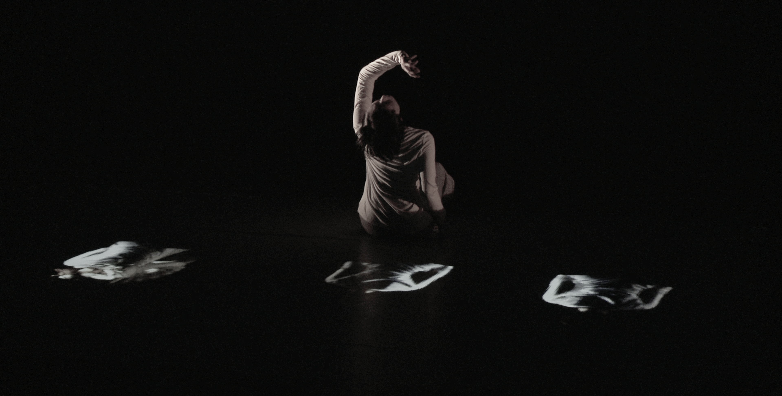hin and elsewhere. The interactive scenography and gestural sound instruments, invisible to the senses, enchant the subtlest of activities and movement, bringing the body into prominence.

We are fully immersed in unstable sonic architectures, which dissolve the dancer’s micro-movements into an ocean of ephemeral micro-intelligences. In turn, textural tonalities of the body’s movement cause this sonic ecology to morph, and self transmute in an endless performative feedback: sensually binding, spatially confusing and temporally unsettling. A compelling trans-sensorial universe that will pull you surely, inevitably into its vertiginous trance-like ritual.